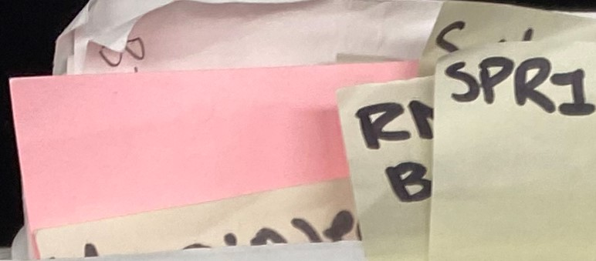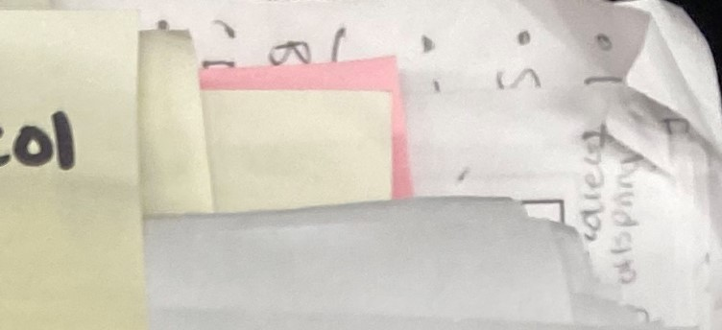Beas

Prot•uo)

|  |  |  |
| --- | --- | --- |
|  |  | cx&s |

RNA SPRI Beads Pro Adapted from:

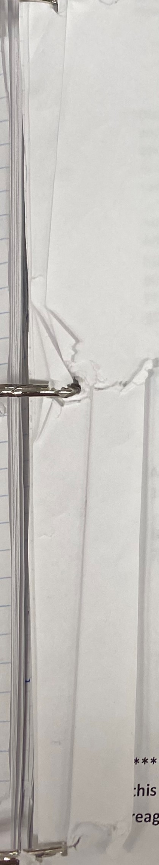

:his

1. Before going into the RNA room, aliquot o t 10g PEG-8000 into a tube and 1mL

Sera beads. To get beads, mix thes very well to resuspend.

Quickly transfer 1 mL to a .5 mL microcentrifuge tube (the beads settle quickly).

1. In one 50mL conical tube, make the "RNA buffer" (24.84mL autoclaved ddH20, 25uL 1M Trisodium citrate, 125uL Tween 20 [10% v/vl, 10.5uL IN HO).

*** NOTE: Check the fridge to see if this is already made***

1. In a new 50mL conical tube (Tube 2; label as RNA SPRI Beads), combine 25mL

5M NaCl, 4.672mL autoclaved ddH20, 50uL 1M Trisodium citrate, and 28uL IN HCI. Cap and mix well.

1. Place the beads on a magnet stand until the supernatant is clear, about 1 min.
2. Remove and discard the supernatant.
3. Add 1 mL of previously prepared "RNA buffer" (step 2) to the bead pellet and close the tube.
4. 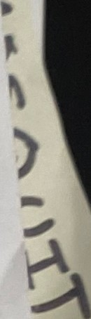Remove the tube from the magnet and resuspend the beads by vortexing for at least 15 seconds. Spin down the liquid with a microcentrifuge.
5. Put the tube back on the magnet until the beads pellet towards the magnet.
6. Remove and discard the supernatant.
7. Repeat steps 6 to 9 twice, for a total of 3 washes.

1 1. On the last wash, remove the supernatant from the beads, and add 1mL from Tube 2 (made in step 3) to the beads. Remove from magnet and resuspend the beads by vortexing. Remove liquid from the lid by briefly centrifuging the tube so no bead pellet forms.

1. To tube 2 add 10g of PEG-8000 (final concentration will be 20% in final solution).
2. Fill tube 2 to —48mL using autoclaved ddH20. Add water slowly as to make sure you don't hit the 50mL mark!!!
3. Mix the conical for —3-5 minutes until the PEG goes into solution (solution, upon sitting, should be clear).

15.Add 250uL Tween 20 [10% wv].

1. Make sure the beads are resuspended (see step 1 1), and add the beads into Tube 2. Fill tube to 50mL if not already there using autoclaved ddH20.
2. Gently mix tube 2 until the conical vial is brown. Tube 2 is now the complete RNA SPRI bead mix.

*** *NOTE: Use the bead reagent stocks that are already made! Also make sure to perform in the RNA room in the hood to prevent RNase contamination. Make sure to clean

•eagent tubes well with RNase away before using in RNA hood* ***